Prof. Dr. Joanna Ozga

\i 28.04.2020

'■ ’ p'. ’J •

Zv'''/

**Hochschule Fulda**

University ofApplied Sciences

Introduction to Business 2 Motives for Internationalization

International Business Management

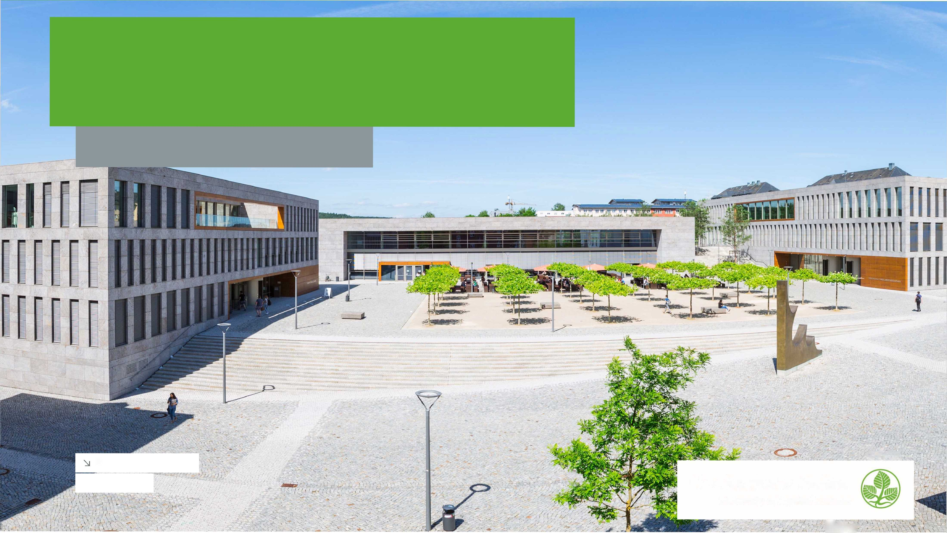

Recapitulation from the last week

1. Explain four dimensions in the Integration/Responsiveness-Framework
2. Explain forces for global integration and local responsiveness
3. Highlight the advantages and disadvantages of each dimension in the I/R-Framework
4. Explain three levels in the I/R-Framework
5. Explain three dimensions in the AAA-Framework
6. Perlmutter's EPRG Concept (from the discussion board)

**Hochschule Fulda**

University ofApplied Sciences



2

Learning objectives

\Explain main motivesforinternationalization

Explain van Tulder's approach of dealing with motivation constellations

**Hochschule Fulda**

University ofApplied Sciences



3

Average labor cost for the manufacturing industry in

Europe in

2018*, by country (in euro

per

Labor cost per hour forthe manufacturing industry in European countries 2018

Labor cost in euro per hour in €

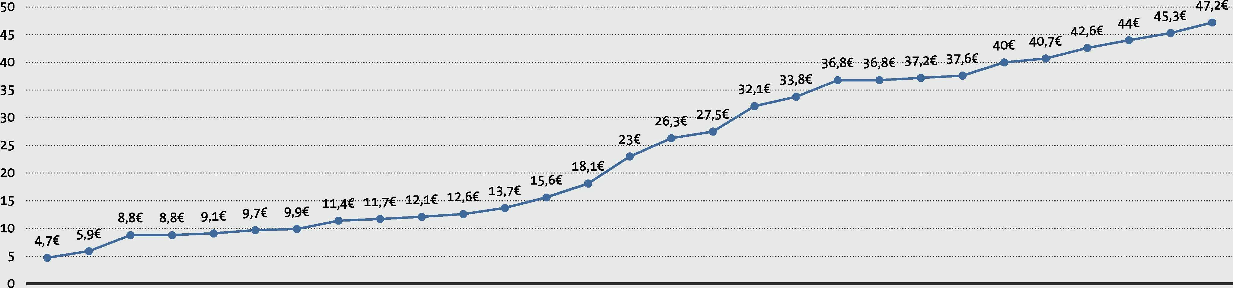



Note: Europe; 2018

Source(s): EurostatlD 950053

* Labor costfor LCI (compensation of employees plustaxes minus subsidies). Data coverage correspondstocode C of NACE Rev 2 (Manufacturing).** 2017 Data

6

**Hochschule Fulda**

University ofApplied Sciences



The Global Competitiveness Index 4.0 framevvork

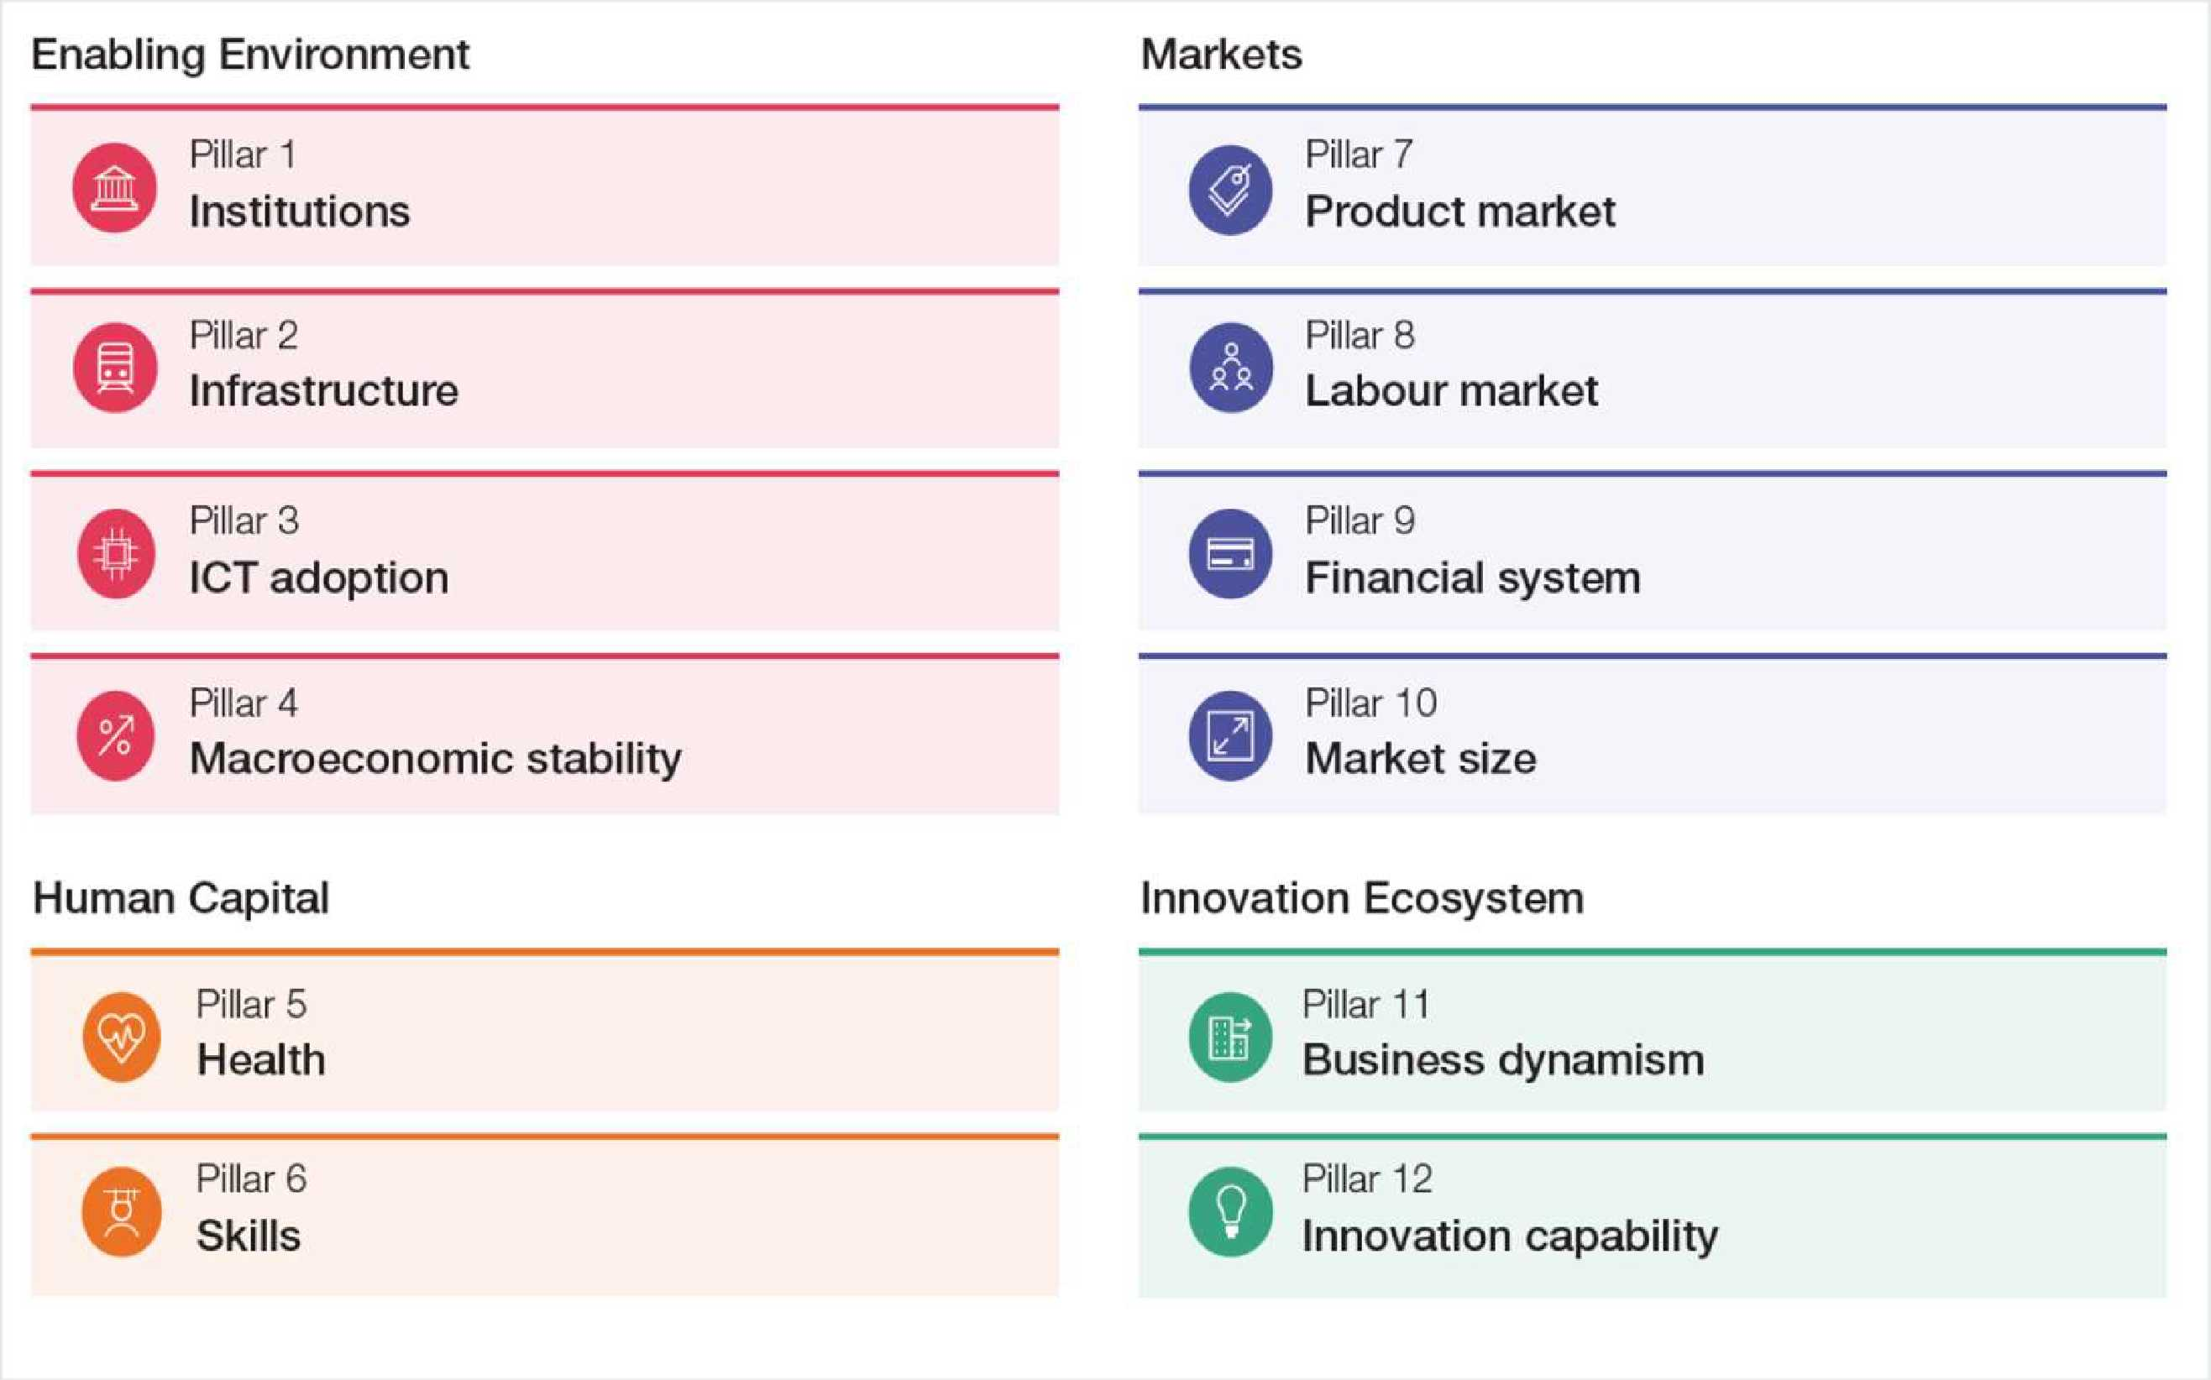

5 Source: World Economic Forum 2019, The Global Competitiveness Report 2019, available:

[http://www3.weforum.org/docs/WEF TheGlobalCompetitivenessReport2019.pdf](http://www3.weforum.org/docs/WEF_TheGlobalCompetitivenessReport2019.pdf)

**Hochschule Fulda**

University ofApplied Sciences



Regional Performance by Pillar

Average score (0-100)

Enabling Environment

Human Capital

Markets

Innovation

Ecosystem

|  |  |  |  |  |  |  |  |  |  |  |  |  |
| --- | --- | --- | --- | --- | --- | --- | --- | --- | --- | --- | --- | --- |
| Region (alphabetical order) | Institutions | Infastructure | ICT adoption | ,Q E o  i  §  8 $ S 75 | Health | Skills | Product market | **©**  S  E  **D s**  **05** | Financial system | Market size | Business dynamism | Inncvation capability |
| East Asia and the Pacific | 61.6 | 74.8 | 70.3 | 89.6 | 83.8 | 67.3 | 62.2 | 66.6 | 74.3 | 67.9 | 66.1 | 54.0 |
| Eurasia | 53.8 | 67.7 | 59.5 | 74.9 | 71.3 | 66.1 | 56.1 | 63.5 | 52.0 | 50.3 | I 61.9 | 35.5 |
| Europe and North America | 64.7 | 79.7 | 70.4 | 92.6 | 89.1 | 74.6 | 60.0 | 66.4 | 70.9 | 60.1 | 68.3 | 58.1 |
| Latin America and the Caribbean | 47.1 | 61.3 | 50.9 | 73.7 | 82.2 | 58.7 | 51.6 | 55.9 | 60.3 | 51.2 | 53.8 | 34.3 |
| Middle East and North Africa | 55.5 | 70.5 | 57.6 | 75.3 | 80.8 | 62.9 | 56.7 | 54.8 | 63.7 | 59.9 | 58.2 | 41.3 |
| South Asia | 50.0 | 59.2 | 35.1 | 74.7 | 68.4 | 50.1 | 45.8 | 51.5 | 60.0 | 67.7 | 57.8 | 36.3 |
| Sub-Saharan Africa | 46.9 | 45.0 | 34.3 | 69.4 | 50.8 | 44.3 | 49.3 | 54.6 | 50.8 | 40.4 | 51.8 | 29.4 |

Source: World Economic Forum analysis.

Note: See the At a Glance section on page xiii for regional classifications. Darker shades indicate better performance.

Source: World Economic Forum 2019, The Global Competitiveness Report 2019, available:  
[http://www3.weforum.org/docs/WEF TheGlobalCompetitivenessReport2019.pdf](http://www3.weforum.org/docs/WEF_TheGlobalCompetitivenessReport2019.pdf)

**Hochschule Fulda**

University ofApplied Sciences



6

Alternative Motivesfor Internationalisation

7

Efficiency Seeking

Follow-  
the-  
Leader

Strategic Asset  
(or Capability)  
Seeking

Market  
Seeking

(Natural) Resource  
Seeking

**Hochschule Fulda**

University ofApplied Sciences

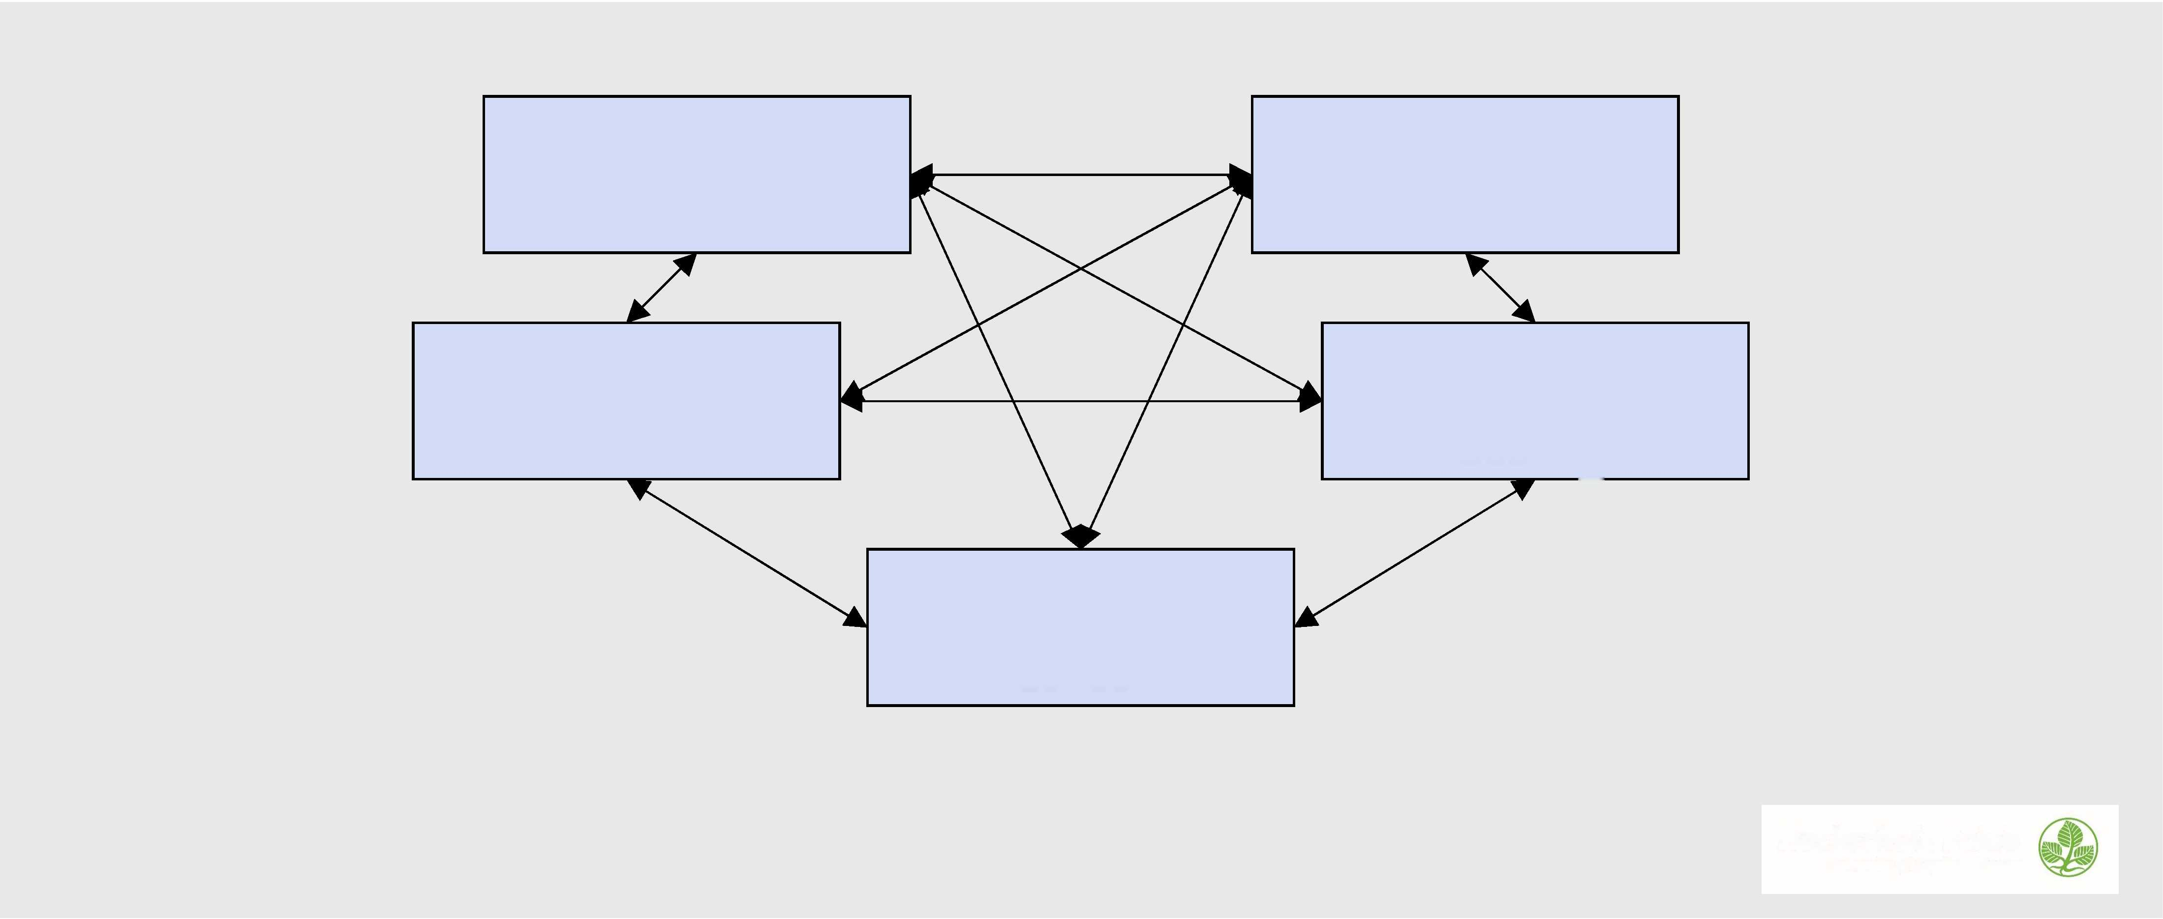

Motivation for Internationalization

|  |  |  |
| --- | --- | --- |
| Type of motive | Intemationalization motive | Dominant approach |
| Intrinsic motives  Efficiency approaches; resource based-view; and leaming  Mixed motives  Competitiveness and positioning in sector;  co-evolution  Extrinsic motives Bargaining/negotiation and game theoretical approaches; stakeholder approach; institutions-based view; bundled resources | Market-seeking Efficiency-seeking Resources-seeking  (strategic) asset-seeking Sector: bandwagon effects, e.g. in country selection; follow the client; risk minimizing Monopoly/oligopoly effects; follow the competitor Home: escape motives from home country; strategic extension of home country Host: high/low barriers to entry | Micro: Intemational management  Meso: IB, intemational strategy  Macro: Intemational (political) economics |

Credit: van Tulder, R. (2015), "Getting all motives right: a holistic approach to internationalization motives of companies", Multinational Business Review, Vol. 23 No. 1, p. 38

***Hochschule Fulda***

*University ofApplied Sciences*

8

Motivation constellations

**Secondary motivations**

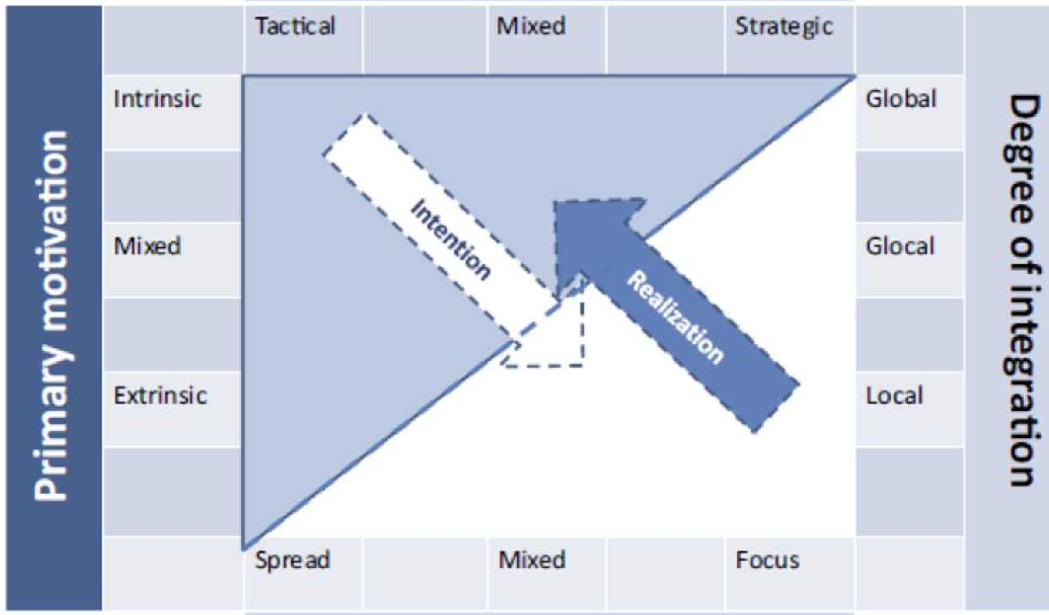

**Degree of coordination**

Credit: van Tulder, R. (2015), "Getting all motives right: a holistic approach to internationalization motives of companies", Multinational Business Review, Vol. 23 No. 1, p. 47

**Hochschule Fulda**

University ofApplied Sciences



9

Internationalization Trajectories

**STAGE 0:**

**TRADE ORIENTATION**

**Secondary motivations**



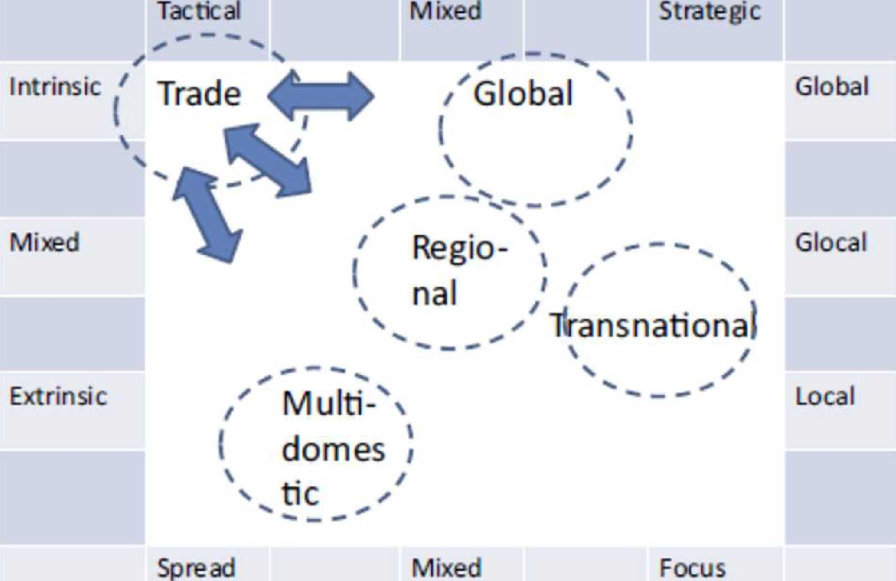



**Degree of coordination**

Credit: van Tulder, R. (2015), "Getting all motives right: a holistic approach to  
internationalization motives of companies", Multinational Business Review, Vol. 23 No. 1, p. 47

**Hochschule Fulda**

University ofApplied Sciences



10

Motivational Constellations and Internationalization Stages

**STAGE I:  
TRIGGER EVENT**

**IMPLEMENTATION**

llransnational

domes i

**Mixed**

**Focus**

Degree of coordination

|  |  |  |  |
| --- | --- | --- | --- |
|  | **Mixed** |  | **Strategic** |

Credit: van Tulder, R. (2015), "Getting all motives right: a holistic approach to internationalization motives of companies", Multinational Business Review, Vol. 23 No. 1, p. 50

**STAGE III:**

**STAGE II: INTERNAL**

Degree of coordination

MOliK,  
domes

**Hochschule Fulda**

University of Applied Sciences

**Degree of integration**

|  |  |  |  |  |  |
| --- | --- | --- | --- | --- | --- |
|  | **Mixed** |  | **Strategic** |  |  |

11

|  |  |
| --- | --- |
| **Tacticai** | **Mixed** |
|  | *~* |

